~Asia-China-Mirror-Liaoning-Jade

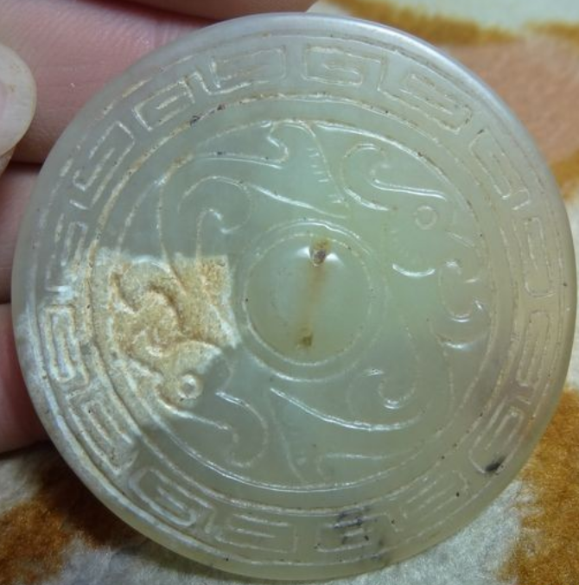

China LiaoNing Serpentine Jade Bi 2 Phoenix

Size:50x50x5(mm)

**Liaoning** 遼寧; a northeast province of the People's Republic of China, named for the Liao River that flows through the province and "Níng" meaning "peace." This mirror carved from jade may have been produced by the Mongolian peoples who controlled the area prior to the period when the Ming Empire took control of Liaoning in 1371, just three years after the expulsion of the Mongols from Beijing.